Exp 16: mmWave Loss Components (28 GHz & 60 GHz)

AIM
To simulate and compare the Reflection Loss, Penetration Loss, and Atmospheric Loss of mmWave signals at 28 GHz and 60 GHz over varying distances using MATLAB.

THEORY (Short & Clear)
1. mmWave Communication
- Operates in high-frequency bands (24–100 GHz).
- Used in 5G due to high bandwidth but suffers higher propagation losses.
2. Reflection Loss
- Calculated using Fresnel reflection coefficient.
- Depends on incident angle and wall permittivity.
3. Penetration Loss
- Higher frequencies penetrate walls poorly → more loss at 60 GHz.
4. Atmospheric Absorption
- O₂ molecules cause strong attenuation at 60 GHz (~0.2 dB/m).
- 28 GHz has lower atmospheric attenuation (~0.06 dB/m
PROCEDURE (Exactly 6 Lines)
- Define frequency, distance range, wall permittivity, and atmospheric loss parameters.
- Compute Fresnel reflection coefficient for each frequency and convert it to dB loss.
- Estimate penetration loss using a frequency-dependent model.
- Compute atmospheric loss by multiplying attenuation (dB/m) with distance.
- Store all three loss components for 28 GHz and 60 GHz.
- Plot reflection, penetration, and atmospheric losses against distance for comparison.

PSEUDO CODE:
START
DEFINE frequencies = [28 GHz, 60 GHz]
DEFINE distances = 1 to 100 meters
DEFINE permittivity and incident angle
DEFINE atmospheric attenuation values
FOR each frequency
FOR each distance
Compute Fresnel reflection coefficient → ReflectionLoss
Compute frequency-based penetration loss → PenetrationLoss
Compute AtmosphericLoss = attenuation × distance
END FOR
END FOR
PLOT Reflection, Penetration, and Atmospheric Losses vs Distance
END

CODE:
clear; clc; close all;

%% PARAMETERS
frequencies = [28e9 60e9]; % Frequencies in Hz
c = 3e8; % Speed of light (m/s)
distances = 1:1:100; % Distance in meters
epsilon_r_wall = 5; % Relative permittivity of wall
theta_inc = 45; % Incident angle in degrees

% Atmospheric attenuation (dB/m)
atm_loss = [0.06, 0.2]; % 28GHz, 60GHz

%% INITIALIZE ARRAYS
ReflectionLoss = zeros(length(frequencies), length(distances));
PenetrationLoss = zeros(length(frequencies), length(distances));
AtmosphericLoss = zeros(length(frequencies), length(distances));

%% COMPUTE LOS / LOS COMPONENTS
for f_idx = 1:length(frequencies)
f = frequencies(f_idx);

for d_idx = 1:length(distances)
d = distances(d_idx);

% -------- Reflection Loss (Fresnel coefficient, perpendicular polarization) --------
theta_rad = deg2rad(theta_inc);
gamma = (cos(theta_rad) - sqrt(epsilon_r_wall - sin(theta_rad)^2)) / ...
(cos(theta_rad) + sqrt(epsilon_r_wall - sin(theta_rad)^2));
ReflectionLoss(f_idx,d_idx) = abs(gamma)^2; % Power reflection coefficient
ReflectionLoss(f_idx,d_idx) = -10*log10(ReflectionLoss(f_idx,d_idx)+eps); % dB

% -------- Penetration Loss (frequency-dependent) --------
PenetrationLoss(f_idx,d_idx) = 5 + 0.02*f/1e9; % Example: 28GHz ~5.56dB, 60GHz ~6.2dB

% -------- Atmospheric Loss (linear with distance) --------
AtmosphericLoss(f_idx,d_idx) = atm_loss(f_idx) * d; % dB
end
end

%% -------------------- PLOTS --------------------
figure;

% Reflection Loss
plot(distances, ReflectionLoss(1,:),'r','LineWidth',1.5); hold on;
plot(distances, ReflectionLoss(2,:),'b','LineWidth',1.5);

% Penetration Loss
plot(distances, PenetrationLoss(1,:),'r--','LineWidth',1.5);
plot(distances, PenetrationLoss(2,:),'b--','LineWidth',1.5);

% Atmospheric Loss
plot(distances, AtmosphericLoss(1,:),'r-.','LineWidth',1.5);
plot(distances, AtmosphericLoss(2,:),'b-.','LineWidth',1.5);

grid on;
xlabel('Distance (m)'); ylabel('Loss (dB)');
title('mmWave Loss Components at 28 GHz and 60 GHz');
legend('Reflection 28 GHz','Reflection 60 GHz', ...
'Penetration 28 GHz','Penetration 60 GHz', ...
'Atmospheric 28 GHz','Atmospheric 60 GHz');

Output:
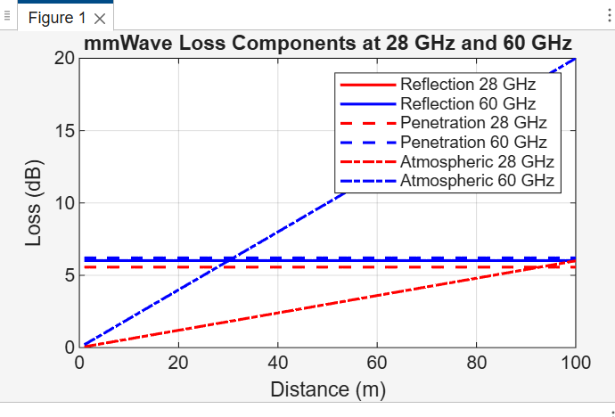

Conclusion:
• 60 GHz experiences significantly higher losses than 28 GHz due to higher penetration loss and strong atmospheric absorption.
• Reflection loss remains similar over distance but depends strongly on wall material and frequency.
• Atmospheric absorption increases linearly with distance, dominating total loss at 60 GHz.
• The results justify why 28 GHz is favored for longer-range 5G links, while 60 GHz is suitable mainly for short-range indoor or hotspot communication.

